b) Output from the Implemented DDA Program:
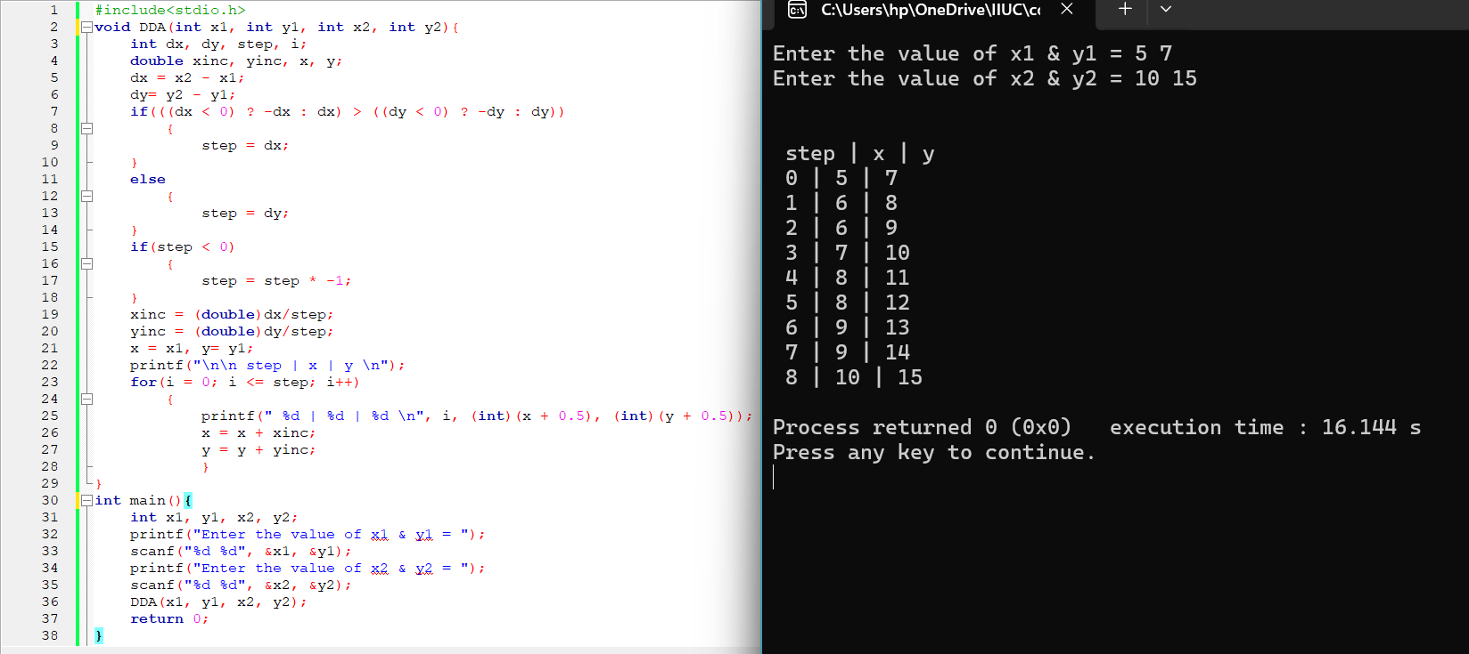
Figure – 01: Source Code and Output for the DDA Code

A mismatch occurs at step 4, where the mathematical output is (7, 11), whereas the program produces (8, 11).

c) Plotting the Line Using WinBGI graphics console (C/C++):
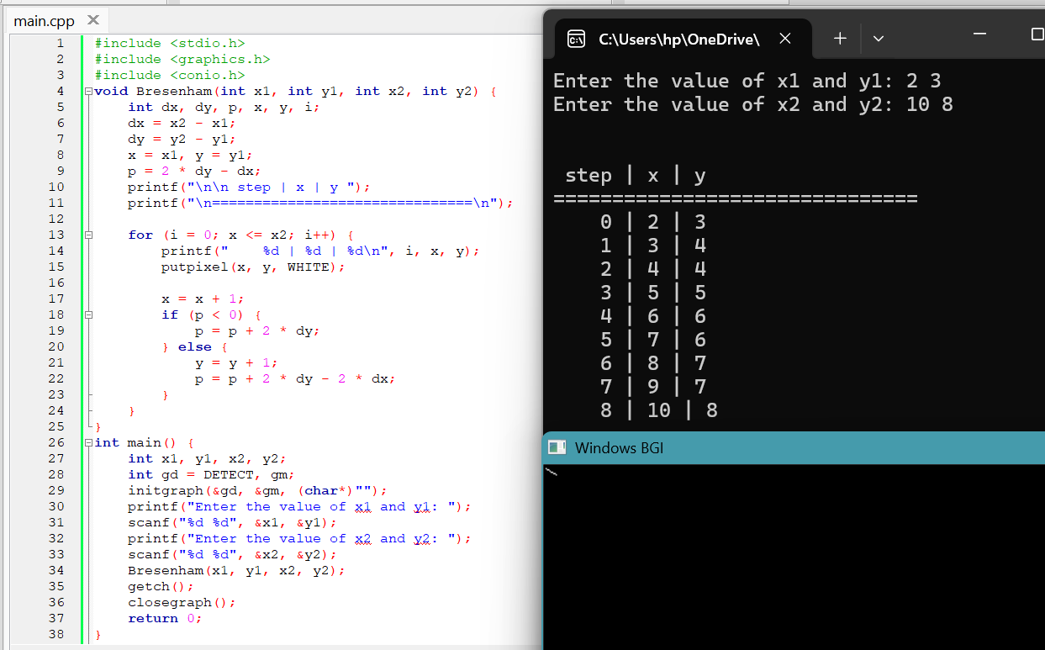
Figure – 02: Source Code and Output for the line drawn using Bresenham Algorithm

d) DDA algorithm Output for the same line:
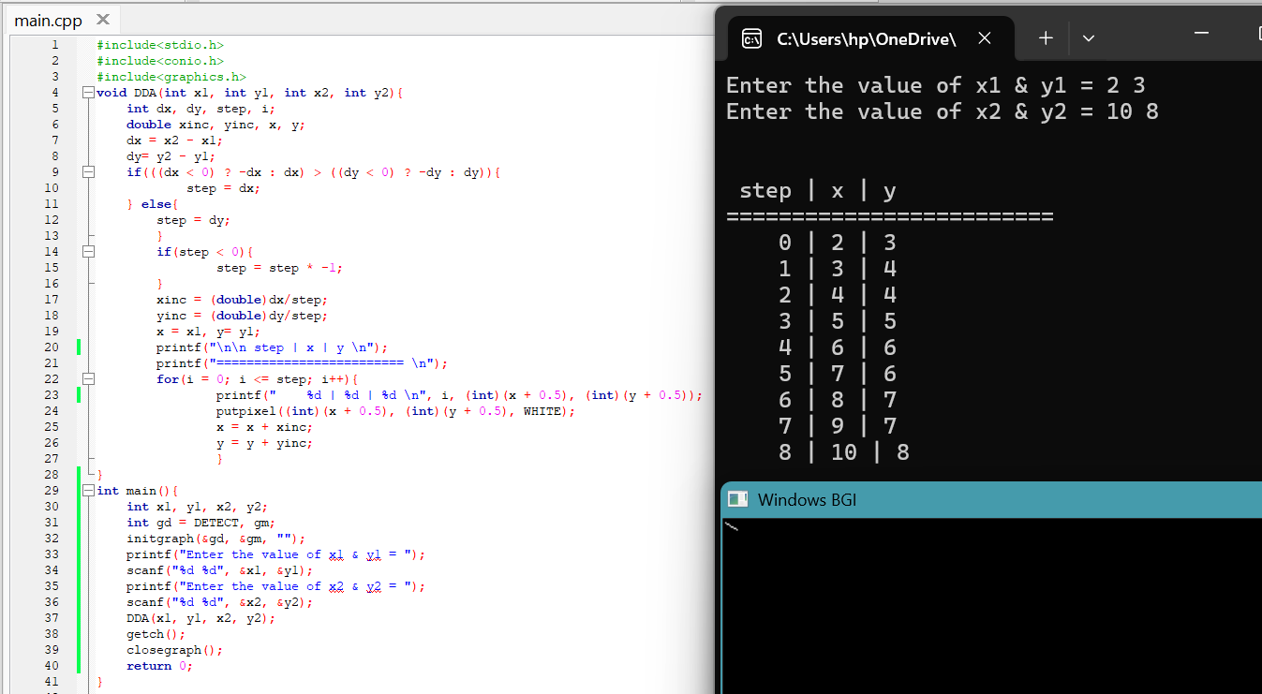
Figure – 03: Source Code and Output for DDA Algorithm for the same line

